

New Caregiver Account Claiming and Multi-Factor Authentication Set-up
Dear Caregiver,

Welcome to Providence! We are grateful for you and your dedication to care for our community during this time.

Successfully obtaining access to your Providence Account by “claiming your account” and setting up “Multi-Factor Authentication (MFA)” must be completed prior to your orientation date and will ensure you are ready for your first day. You may use a smartphone or computer to claim your account. Once you have successfully claimed your account, you may complete additional orientation training elements.

Claiming your network account and setting up your MFA will take about 15 minutes. Help resources are listed below, and there will be onsite support during the training day(s) for those unable to successfully claim their account prior to arrival.

Self Service
Use a computer, tablet, or smartphone to visit https://access.providence.org/. Follow the directions at your own pace. Detailed instructions are also found below on page two.



Need help?
If you have issues with claiming your account or setting up your MFA, please connect with clinical informatics for assistance. Virtual support is available from 2/25/26 - 2/27/26 from 0900-1700 PST and 2/28/26 from 0900-2200 PST

For virtual support with account claiming or training - Click here to connect with a live support person
To call in for support dial: (323) 813-9520 when prompted, enter the conference ID: 345 702 628#
Thank you so much for joining us in serving our patients and their families. We are excited to work with you to
deliver great care.

Claim Your Account
Up to 3 days prior to orientation, you may be able to claim your Providence Account. If you are unsuccessful there will be support on-site during Induction and Orientation. It is helpful to read these instructions in their entirety before proceeding. You will not be able to claim your account until Providence processes it
- Go to an internet browser and type: access.providence.org.

- Choose Claim Your Account and Configure Multi-Factor Authentication
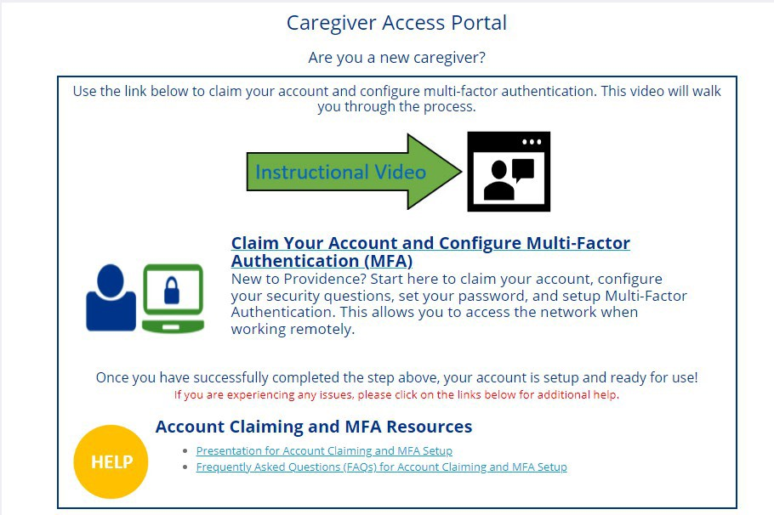
Click here to claim your account
*This instructional video is designed for our standard new hires and may include information that does not apply to replacement workers. Please ignore any orientation guidance or references to applications like Genesis.
- Enter personal information to link you to your account. You will be prompted to create a password.
Remember this password!
- When you get to the final screen showing the following information, Take a screenshot!
Network ID: ______________________________________
User Principal Name: _______________________________
Employee ID: ______________________________________ Email Address: ____________________________________
- You will be taken to a Microsoft log-in screen, enter your new Providence Email Account. You took a screenshot of this during step 4. (emails are often firstname.lastname@providence.org)
- Enter the new password you just created.
- A screen will tell you it needs more information, hit Next.
- It will prompt you to download an Authenticator App, DON’T DO THIS! *
*You may use the authenticator app if you prefer it for MFA, but these instructions explain how to set up MFA using the text method.
- Instead on the bottom of the screen choose, “I want to use a different method”
- Click the dropdown arrow and choose phone.
- Choose United States and enter your phone number on the next line and ensure “Text” is checked. Click the next button.
- You will receive a numeric code via text that you will enter on the next screen.
You are done with claiming your account

